“ANALYSIS OF NEW PRODUCT DEVELOPMENT RESEARCH
To
Kotak Mahindra Bank LTD”

A PROJECT REPORT SUBMITTED IN PARTIAL FULFILLMENT OF THE
REQUIREMENTS FOR THE AWARD OF DEGREE
MBA
MASTER OF BUSINESS ADMINISTRATION (Marketing)

Submitted by:
V. Ajay Kumar
(24361E0003)
Under the guidance of:
B. Anuradha
Assistant Professor – MBA

Department Of Master of Business Administration
JAYAPRAKASH NARAYAN COLLEGE OF ENGINEERING
UGC Autonomous Institution
(Affiliated to JNTUH)
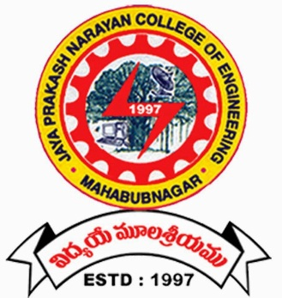
DHARMAPUR, MAHABUBNAGAR-509001 (TELANGANA) 2024-26
JAYAPRAKASH NARAYAN COLLEGE OF ENGINEERING
UGC Autonomous Institution
Dharmapur, Mahabubnagar-509001 (Telangana)
(Affiliated to J.N.T.U.H.)

Department of Master of Business administration

CERTIFICATE
This is to certify that the project entitled “ANALYSIS OF NEW PRODUCT DEVELOPMENT RESEARCH – KOTAK MAHINDRA BANK LTD” is a bonafide work done by V AJAY KUMAR (24361E0003) in partial fulfillment of the requirement of the award for the degree of Master of Business administration” from J.N.T.U. Hyderabad during the year 2024-2026.

Dr.M.Madhu Mohan
Internal Guide Head of the Dept.
B. Anuradha
Head of the Dep

EXTERNAL EXAMINER

ACKNOWLEDGEMENT
It is indeed a pleasant task to thank the people who have contributed towards the successful completion of this project.
Firstly, I would like to express my gratitude to Dr.P.Krishna Murthy Principal, Jayaprakash Narayan College of engineering, for permitting us to undertake this project.
I express my sincere thanks to Prof. Dr.M.Madhu Mohan, head of the department, for extending the strategic support and encouragement in executing the task. Working under such an eminent person was my privilege.
I am grateful to the other teaching and non-teaching members of Jayaprakash Narayan College of engineering for granting us the required facilities for completing the project.

AJAY KUMAR V
(24361E0003)

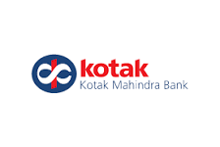

L.NO: 121/06/Proj/2024-26

CERTIFICATE
This is to certify that Mr. AJAY KUMAR has completed his Project report with a title ANALYSIS OF NEW PRODUCT DEVELOPMENT RESEARCH
During his study we found to be satisfactory. And we wish him all the best.

With regards
Mr. Naveen Kumar
Marketing Department

-------------------------------------------------------------------------------------------------------Survey no 54, gayathri westend, 2nd floor, above croma,vikrampuri colony,main road, Hyderabad - 500009

DECLARATION
I, hereby declare that Project Report on “ANALYSIS OF NEW PRODUCT DEVELOPMENT RESEARCH” is submitted in partial fulfillment for the award of degree of master of business administration from Jayaprakash Narayan College of Engineering affiliated to Jawaharlal Nehru Technological University is a record of bonafide work done during the academic year 2024-2026. The results embodied in this Technical report have not been submitted to any other university or institute for the award of any degree.

AJAY KUMAR V

(24361E0003)

